**Strings**  Ashraful Islam Redoy

ID:232-15-178

**1.Write a C program to print “Daffodil” using the string**

#include<stdio.h>

int main()

{

char x[]="Daffodil";

printf("%s\n",x);

return 0;

}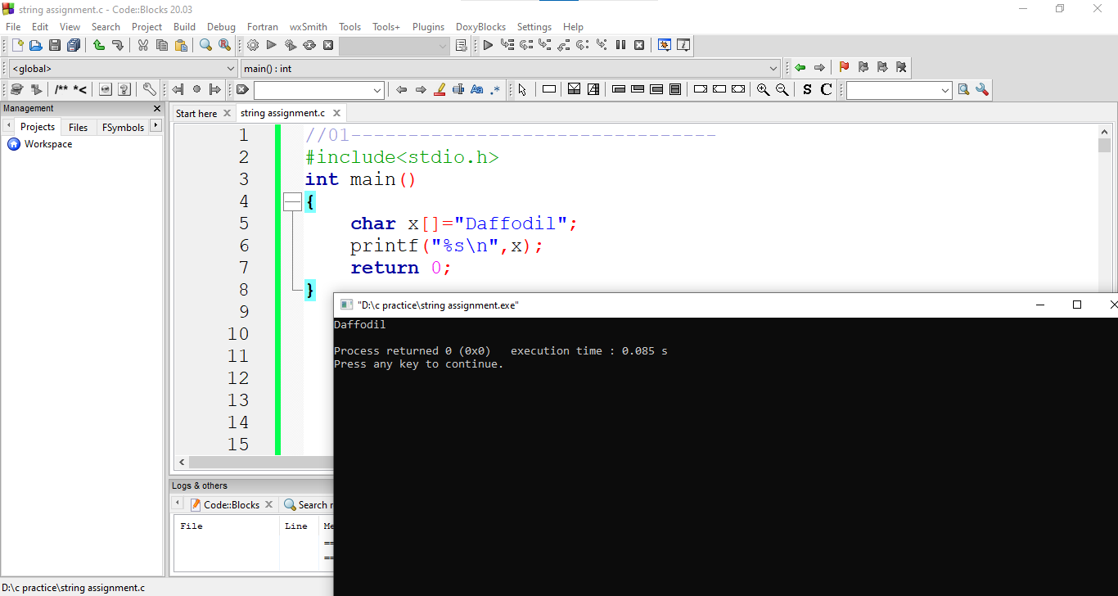

2.**Write a program in C for taking a string from the user and print the string**

#include<stdio.h>

int main()

{

char x[50];

scanf("%[^\n]s",x);

//gets(x);

printf("%s\n",x);

return 0;

}

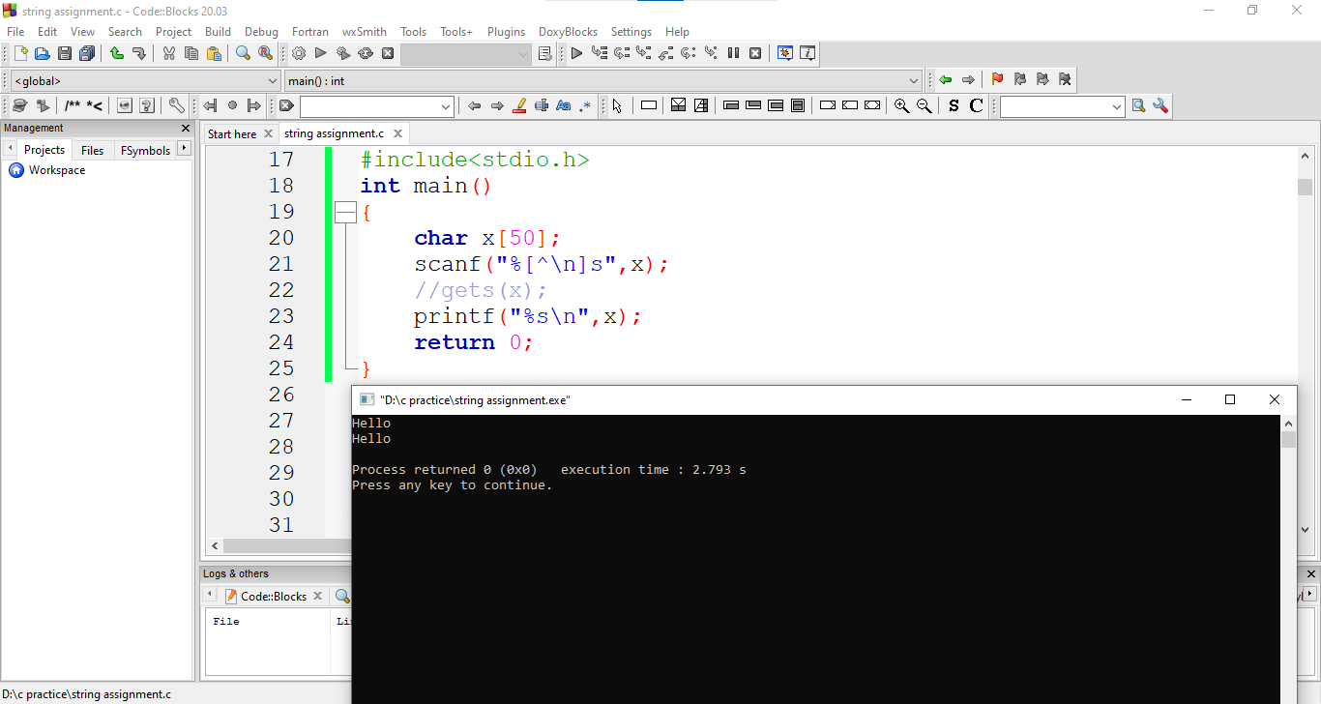

**3. Write a program in C for taking a string from the user and print the string.**

#include<stdio.h>

int main()

{

char x[50];

scanf("%[^\n]s",x);

//gets(x);

printf("%s\n",x);

return 0;

}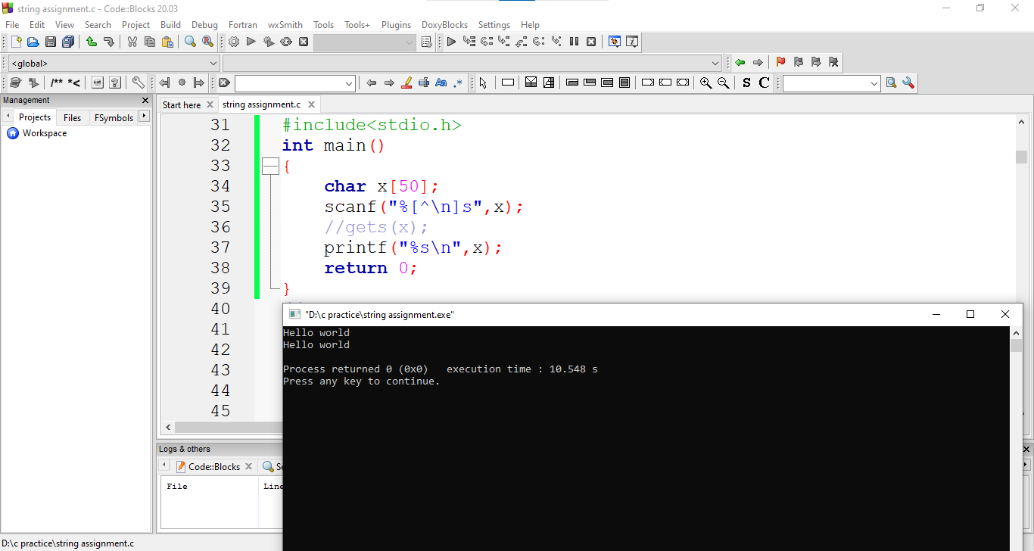

**4. Write a program to find the length of a string.**

#include<stdio.h>

int main()

{

char x[50];

int count=0;

scanf("%[^\n]s",x);

//gets(x);

for(int i=0; x[i]!='\0'; i++)

{

count++;

}

printf("%d\n",count);

return 0;

}

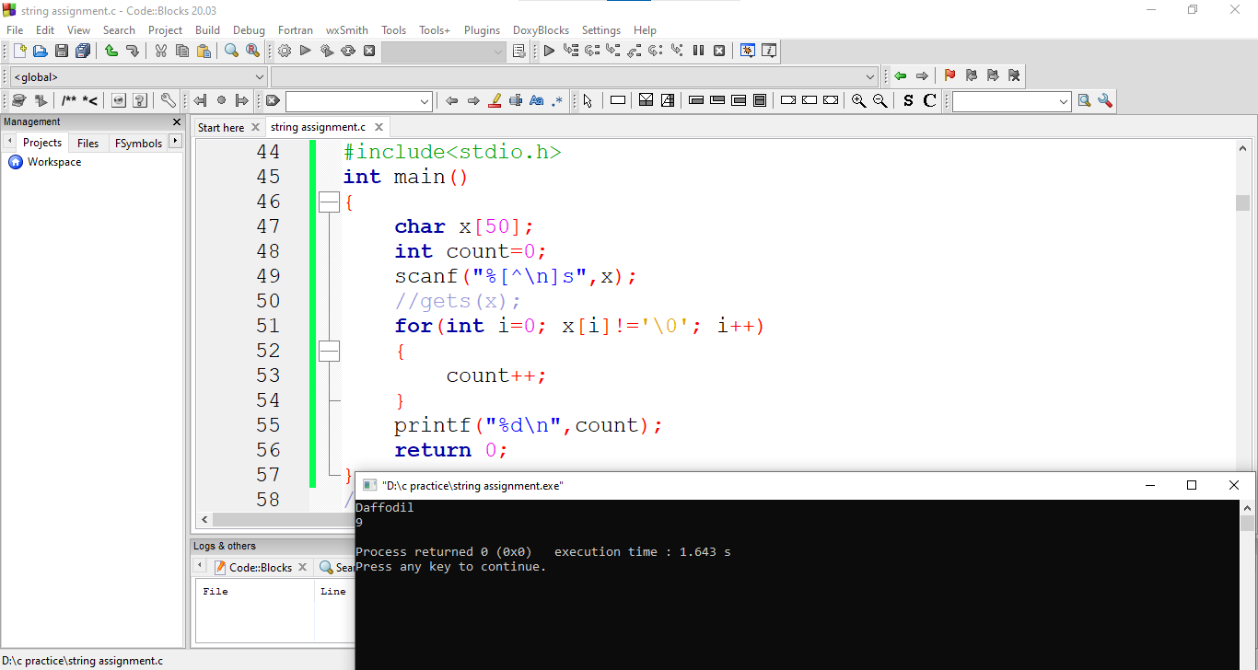

**5. Write a program to compare two strings.**

#include<stdio.h>

int main()

{

char str1[20],str2[20];

int count=0,i;

printf("String 1 :");

gets(str1);

//scanf("%[^\n]s",str1);

printf("String 2 :");

gets(str2);

//scanf("%[^\n]s",str2);

for(i=0; str1[i]!='\0' && str2[i]!='\0'; i++)

{

if(str1[i]!=str2[i])

count=1;

break;

}

if(count==0)

printf("Same\n");

else

printf("Not Same\n");

return 0;

}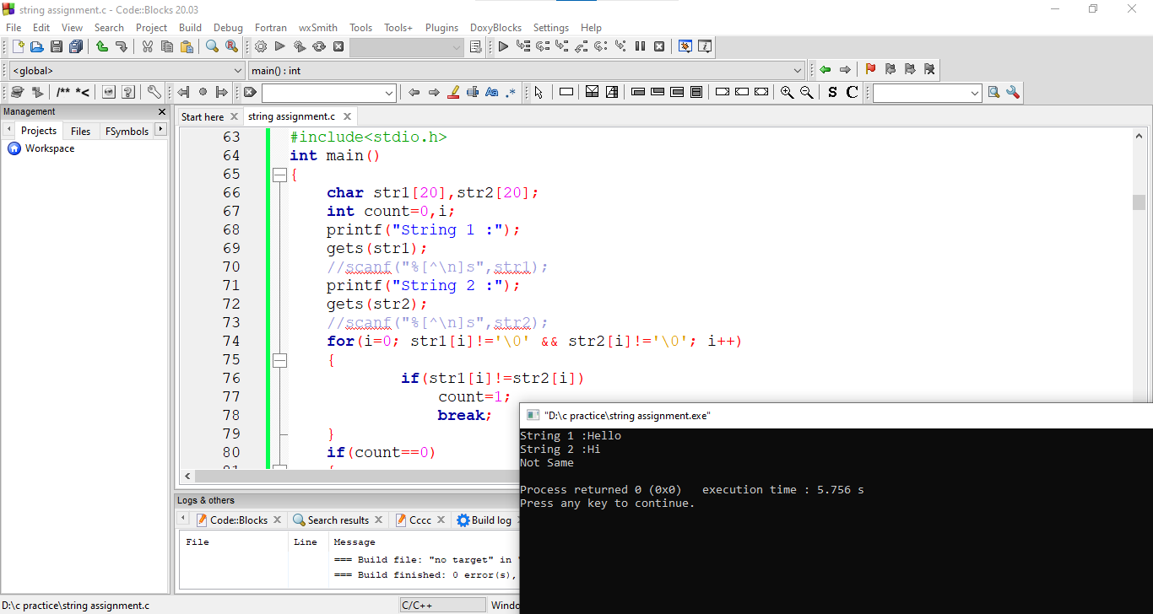

**6. Write a program to copy a string to another string. Suppose you are taking a string from the user and storing that in S1[]. Then, copy the inputted string to the S2[].**

#include<stdio.h>

int main()

{

char x[20],y[20];

printf("String 1: ");

scanf("%[^\n]s",x);

for(int i=0; x[i]!='\0'; i++)

{

y[i]=x[i];

}

printf("String 2: %s\n",y);

return 0;

}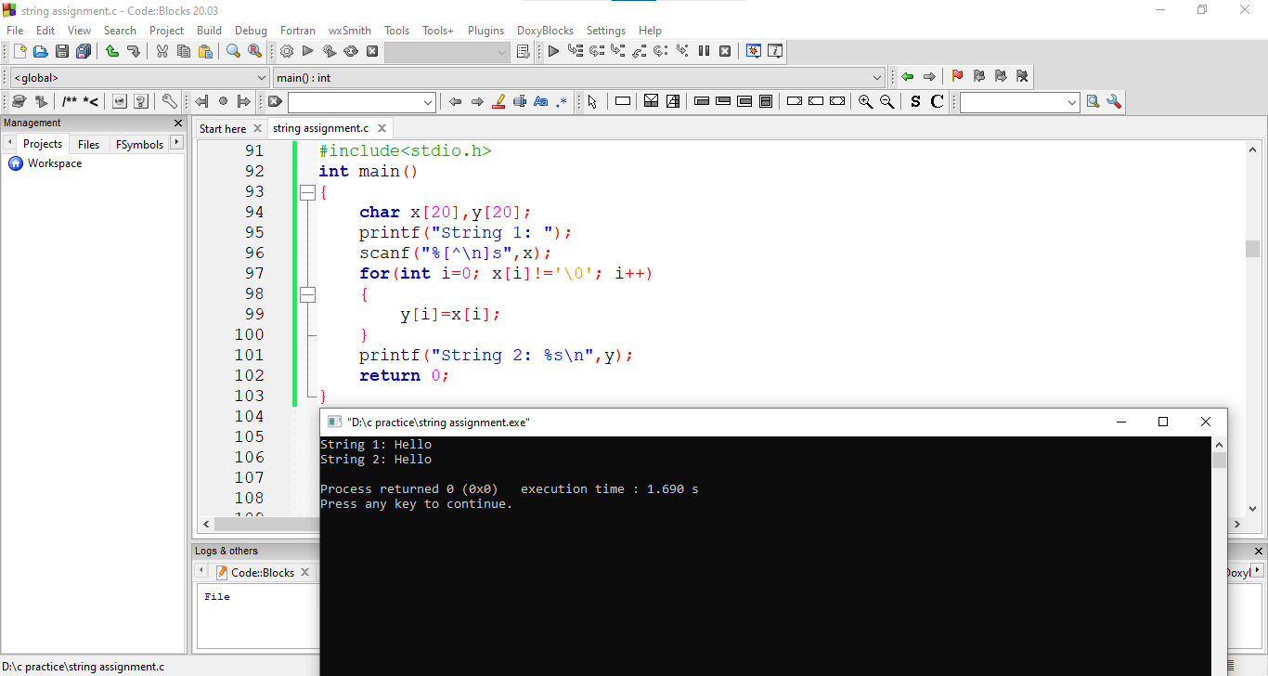

**7. Write a program to merge two strings**.

#include<stdio.h>

int main()

{

char x[40],y[20];

int i,j,count=0;

printf("String 1: ");

scanf("%[^\n]s",x);

fflush(stdin);

printf("String 1: ");

scanf("%[^\n]s",y);

for(i=0; x[i]!='\0'; i++)

{

count++;

}

for(i=0; x[i]!='\0'; i++)

{

x[i+count]=y[i];

}

x[i+count]='\0';

printf("String : %s\n",x);

return 0;

}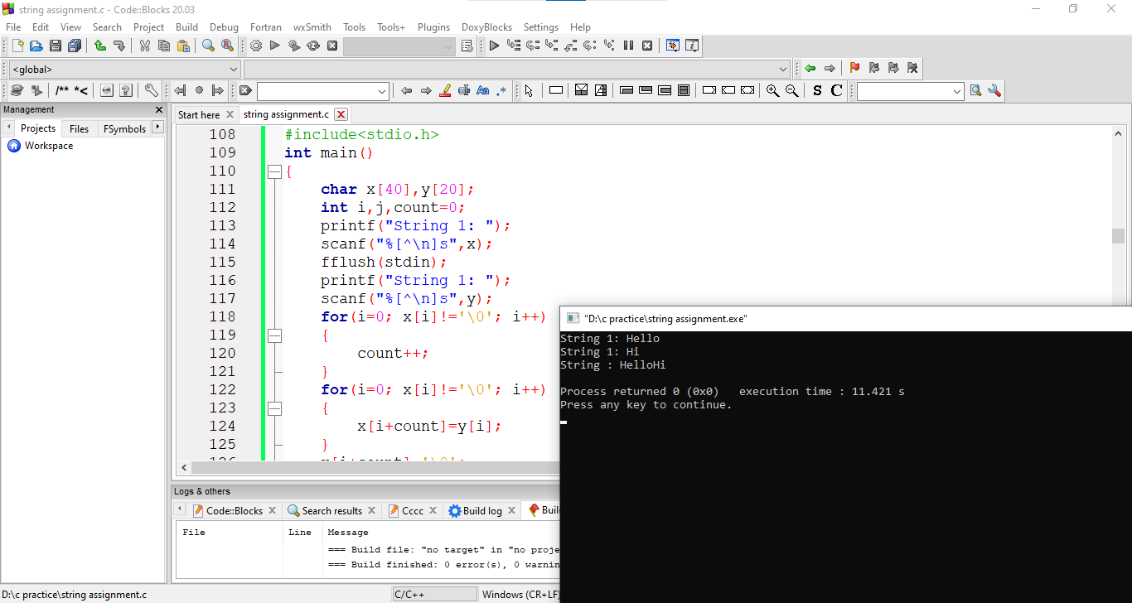

**8.Write a program in C to count the number of letters and digits in a string.**

#include<stdio.h>

int main()

{

char str[20];

int count=0,count1=0;

scanf("%[^\n]s",str);

for(int i=0; str[i]!='\0'; i++)

{

if((str[i]>='a' && str[i]<='z') || (str[i]>='A' && str[i]<='Z'))

count++;

if(str[i]>='0'&& str[i]<='9')

count1++;

}

printf("Letter : %d\n",count);

printf("Digits : %d\n",count1);

return 0;

}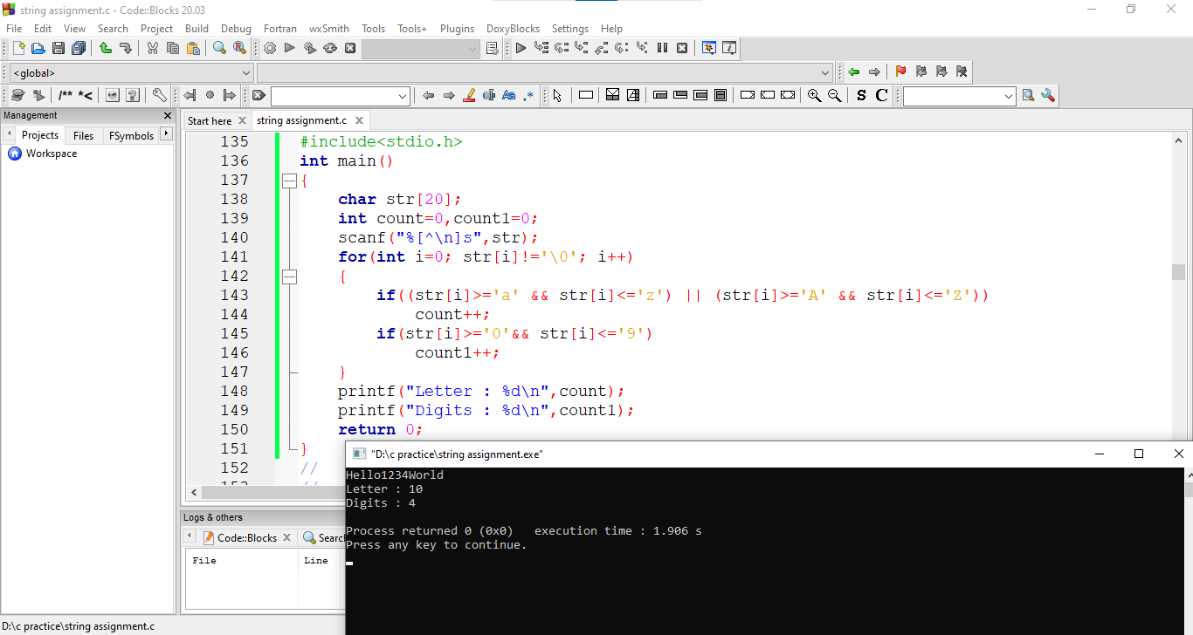

**9.Write a program in C to count the number of vowels and consonants in a string.**

#include<stdio.h>

int main()

{

char str[20];

int count=0,count1=0;

printf("String : ");

scanf("%[^\n]s",str);

for(int i=0; str[i]!='\0'; i++)

{

if(str[i]=='a'|| str[i]=='e'|| str[i]=='i'|| str[i]=='o'|| str[i]=='u'|| str[i]=='A'|| str[i]=='E'|| str[i]=='I'|| str[i]=='O'|| str[i]=='U')

count++;

else

count1++;

}

printf("Vowel : %d\n",count);

printf("Consonant : %d\n",count1);

return 0;

}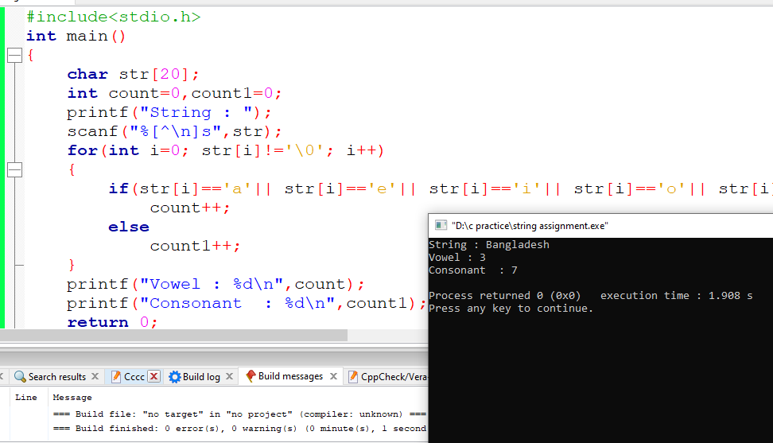

**10. Write a program to search a given character in string.**

#include<stdio.h>

int main()

{

int found=0;

char x[50],ch;

printf("String 1: ");

scanf("%[^\n]s",x);

fflush(stdin);

printf("Character to be Searched: ");

scanf("%c",&ch);

for(int i=0; x[i]!='\0'; i++)

{

if(x[i]==ch)

found=1;

}

if(found==1)

printf("Found\n");

else

printf("Not Found\n");

return 0;

}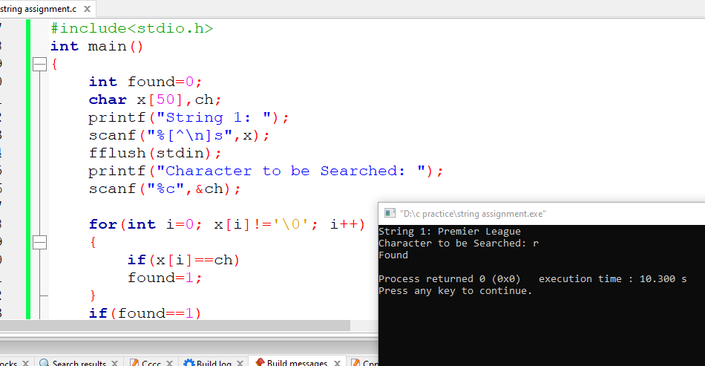

**11. Write a program to search a given character in string**

#include<stdio.h>

int main()

{

int count=0,i;

char x[50],ch;

printf("String 1: ");

scanf("%[^\n]s",x);

fflush(stdin);

printf("Character to be Searched: ");

scanf("%c",&ch);

for(i=0; x[i]!='\0'; i++)

{

if(x[i]==ch)

{

count=i;

break;

}

}

printf("First occurrences of %c is at index %d\n",ch,count);

return 0;

}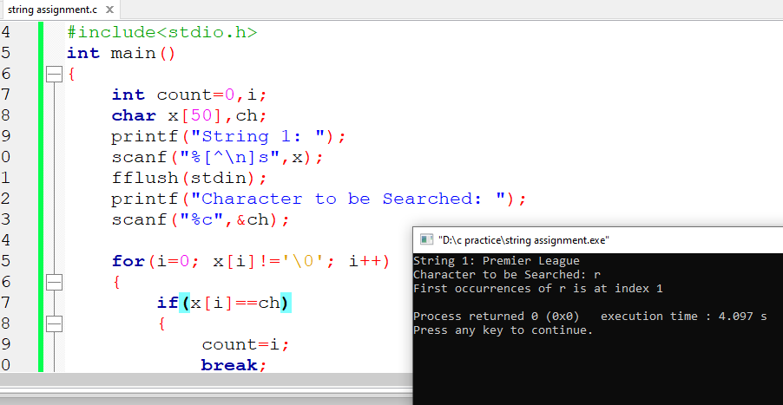

**12. Write a c program all occurrences of a given character in a string.**

#include<stdio.h>

int main()

{

int found=0,count=0;

char x[50],ch;

printf("String 1: ");

scanf("%[^\n]s",x);

fflush(stdin);

printf("Character to be Searched: ");

scanf("%c",&ch);

for(int i=0; x[i]!='\0'; i++)

{

if(x[i]==ch)

{

found=1;

count++;

}

}

if(found==1)

printf("Character r has been occurred %d times\n",count);

else

printf("Not Found\n");

return 0;

}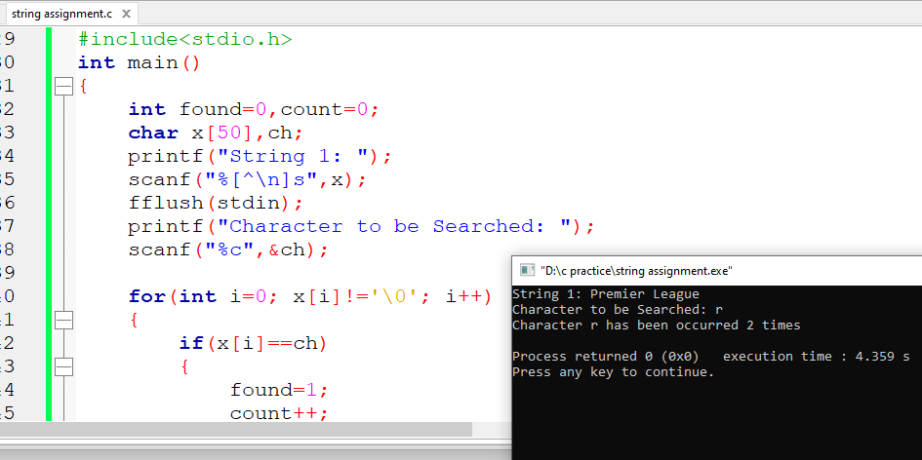

**13. Write a c program to find whether a given string is palindrome or not.**

#include <stdio.h>

#include <string.h>

int main()

{

char x[50],y[50];

int len,i,j,d=0;

fflush(stdin);

gets(x);

len=strlen(x);

for(j=0,i=len-1; i>=0; i--, j++)

{

y[j]=x[i];

}

for(i=0; x[i]!='\0'; i++)

{

if(x[i]==y[i])

d=1;

}

if(d==0)

printf("No\n");

else

printf("Yes\n");

return 0;

}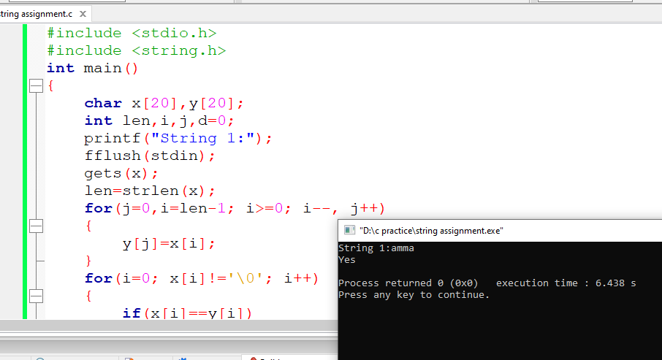

**14. Write a c program that will convert a lowercase string to an uppercase string.**

#include<stdio.h>

int main()

{

char x[30],y[30];

int i;

printf("String : ");

scanf("%[^\n]s",x);

for(i=0; x[i]!='\0'; i++)

{

if(x[i]>='a' && x[i]<'z')

{

x[i]=x[i]-32;

}

else if(x[i]>='A' && x[i]<'Z')

{

x[i]=x[i]+32;

}

}

printf("%s\n",x);

return 0;

}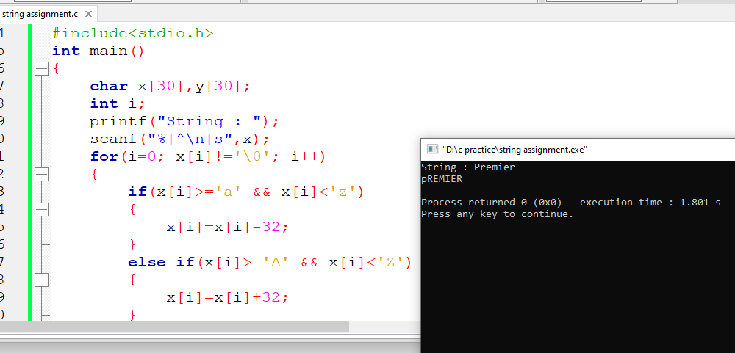

**15. Write a c program to find the number of words in a given string**

#include<stdio.h>

int main()

{

char x[50];

int i,word=1;

printf("string : ");

gets(x);

for(i=0; x[i]!='\0'; i++)

{

if(x[i]==' ' || x[i]=='\n' || x[i]=='\t')

word++;

}

printf("%d words",word);

return 0;

}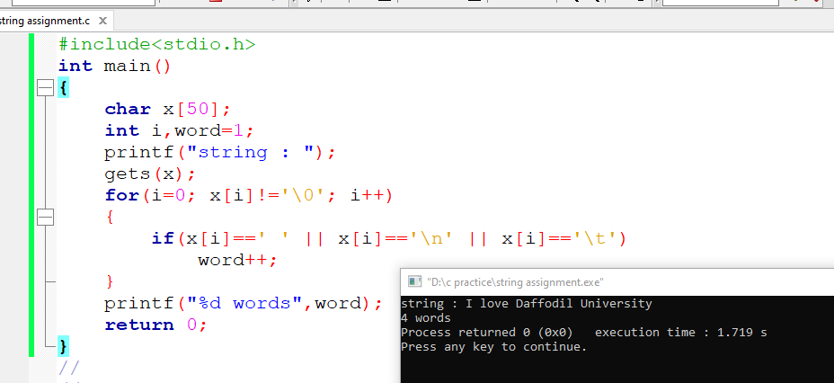

**16. Write a program, which reads your name from the keyboard and outputs a list of ASCII codes, which represent your name.**

#include<stdio.h>

int main()

{

char x[30];

int i;

printf("String : ");

gets(x);

for(i=0; x[i]!='\0'; i++)

{

printf("%d ",x[i]);

}

return 0;

}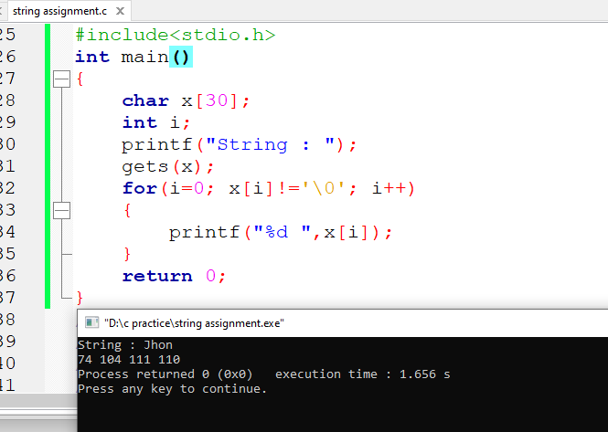

**17. Write a program which will read a string and rewrite it in the alphabetical order.**

#include<stdio.h>

#include<string.h>

int main()

{

int i,j,n,ch1,ch2;

char a[50],temp;

printf("String: ");

scanf("%[^\n]s",a);

n=strlen(a);

for(i=1; i<n; ++i)

for(j=0; j<(n-i); ++j)

{

ch1=a[j];

ch2=a[j+1];

if(ch1>ch2)

{

temp=a[j];

a[j]=a[j+1];

a[j+1]=temp;

}

}

printf("String after arranging: %s",a);

return 0;

}